How to contribute to the Reindeer Project

- Access our online payment site. Register as a user with your name and email address.
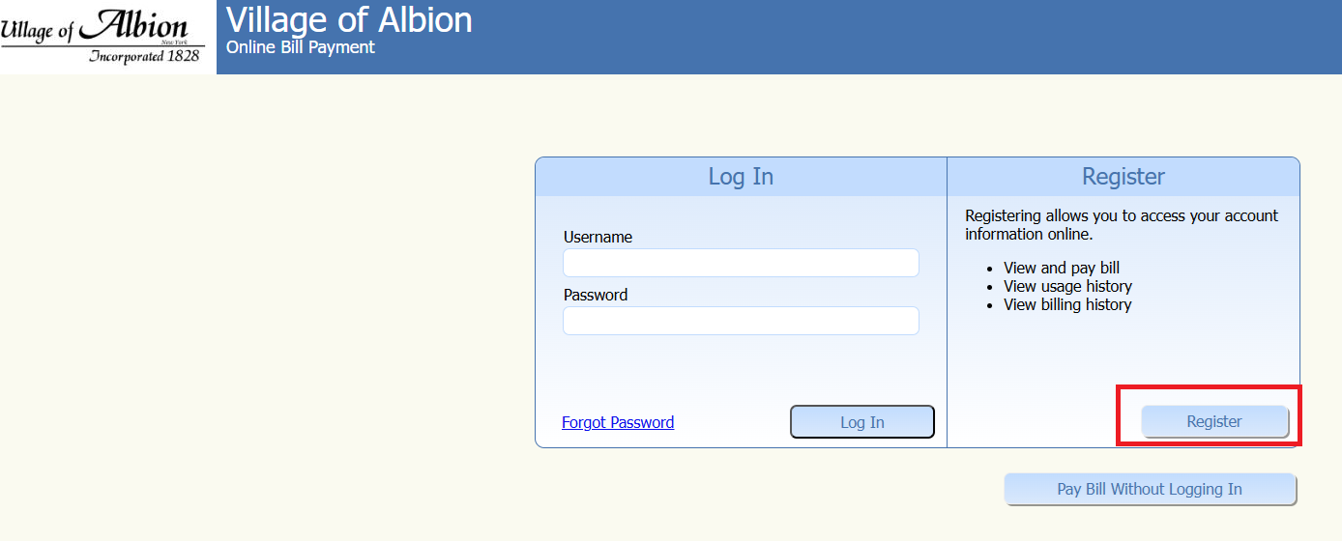

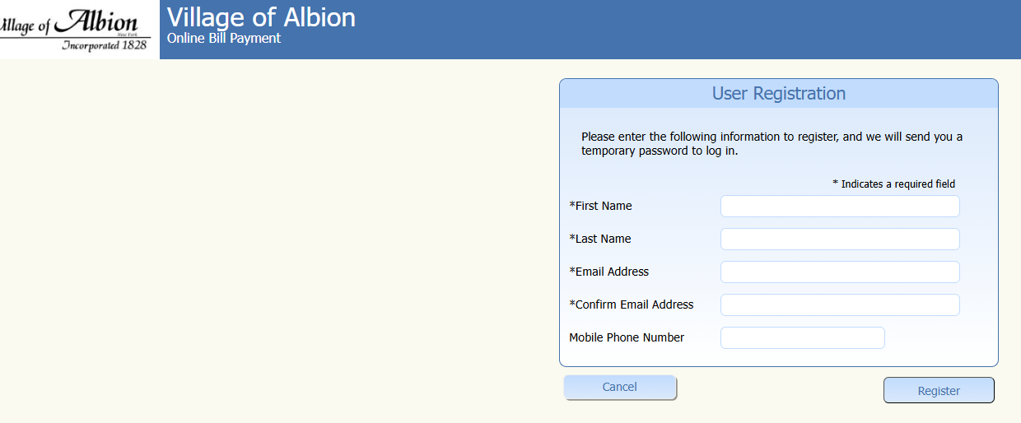

- Check your remail for a temporary password.
- Enter New password

- Select Non-Billed Payments on the left side.
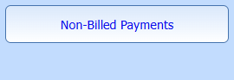

- Enter the Required information and the Payment Method.
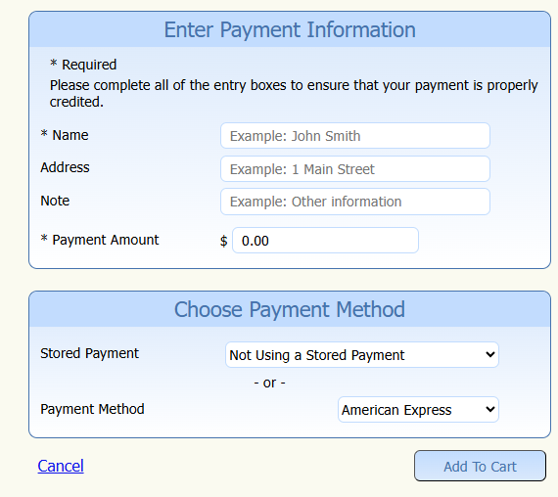

- Review the Payment Method and the Bill Servicing fee.
- Check Out – Enter credit card information.
- Submit the payment

